Electrically Conductive Adhesives with Enhanced Dispense Properties
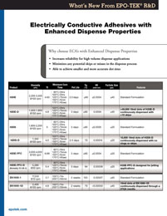 | Epoxy Technology offers Electrically Conductive Adhesives with Enhanced Dispensed Properties. These materials increase the reliability of high volume dispense applications by minimizing the potential for skips or misses in the dispense process, while allowing for smaller and more accurate dot sizes.

