Solar Ribbon Stringing with Epoxies
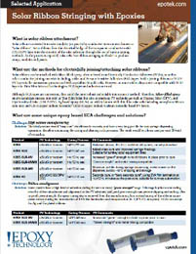 | Solar ribbons can be attached with Silver-filled epoxy, often referred to as Electrically Conductive Adhesives (ECAs), as well as  other conductive joining materials including, solder and Pressure Sensitive Adhesives (PSA) tapes. Solder joining ribbons to TCO/PV layers is the mainstream process used with crystalline Si wafer cells.

